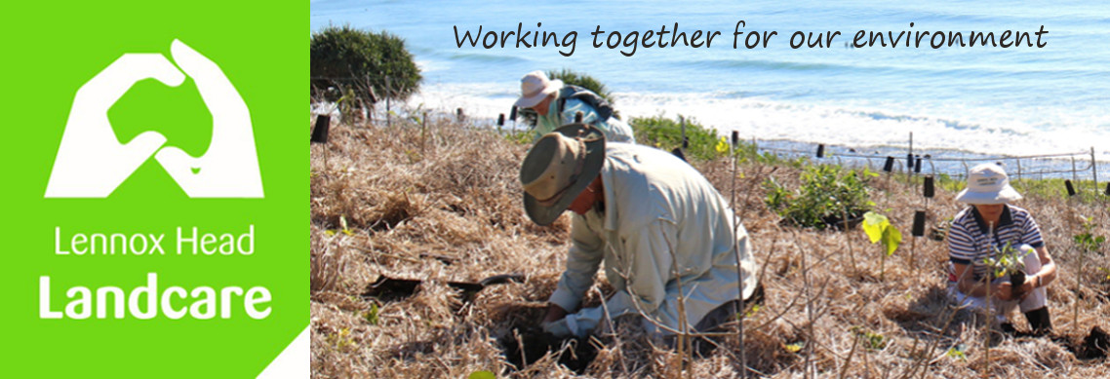

February Newsletter

Hi all

As you can see I haven't managed to sort the issues with the newsletter software yet.

Around Our Sites

The Lake is higher than anyone I can find has ever seen; the grass and the foreshore plantings are taking a beating atm. We theoretically selected plants that could cope with this sort of inundation.... except for all the Dianella!

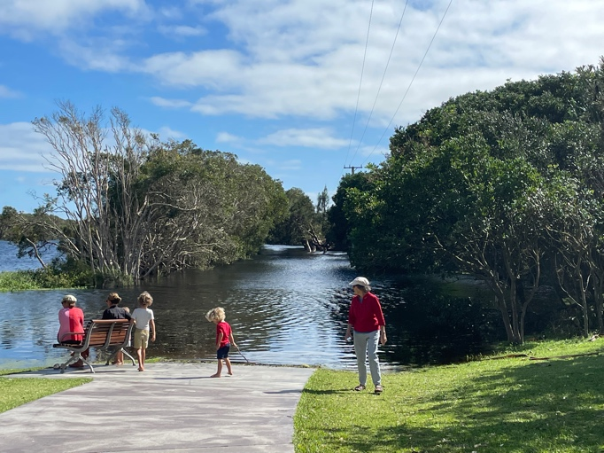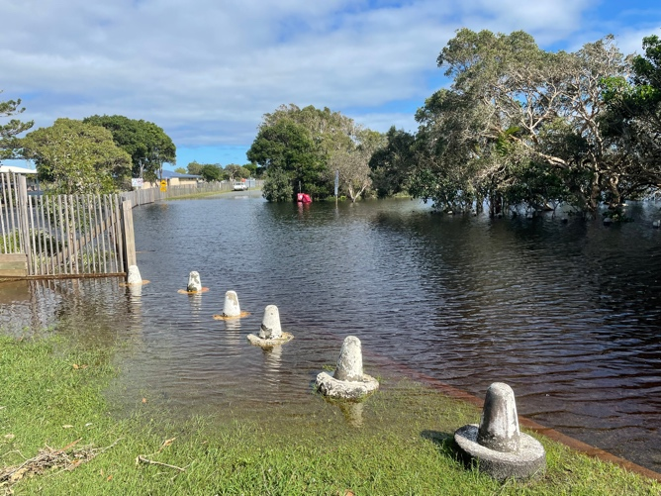

The change to the lagoon @ Boulders is even more spectacular. The speed and volume of water pouring in has punched a channel right through the rocks that used to dam it and now it opens straight on to the beach.

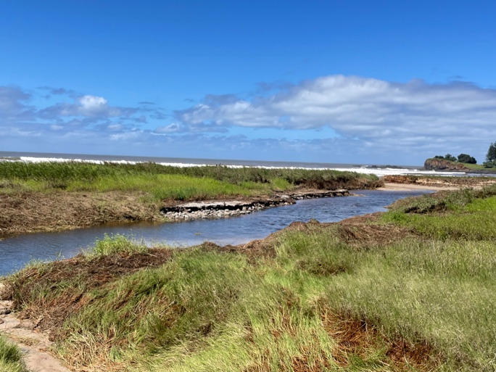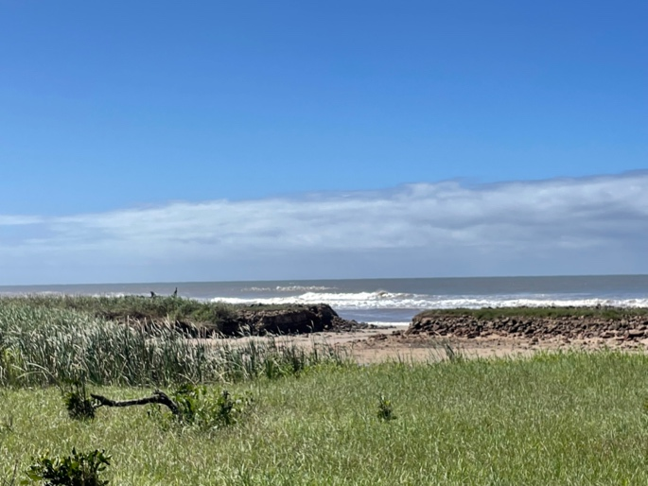

Changes to Regular Working Bees

Now that Daylight Saving time is over we will be starting at 8.30 on Wednesday mornings
and

Instead of the usual Weeks 1 and 3 of each month the plan is to be at Boulders in weeks 1 and 2 in April in order to work around Spider and Kelly being out of town.

Working Bees for April

Wednesday 6th: (8.30am) Boulders - Coast Rd car park

Thursday 7th : (8am) Skennars Head - Rocky Pt car park

Tuesday 12th: (7.30am) Bora Ring - 23 Gibbon St

Wednesday 13th: (8.30am) Boulders - Coast Rd car park

Thursday 14th: (8am) Skennars Head - Rocky Pt car park

Wednesday 20th: (8.30am) William St - opp #55 Pacific Pde

Thursday 21st: (8am) Skennars Head - Rocky Pt car park

Wednesday 27th:(8.30am) Sue's site @ the Lake - near the BBQ @ the SW corner of the Lake
(depending on water levels)

Thursday 28th: (8am) Skennars Head - Rocky Pt car park

Shaun
0448 221 210

