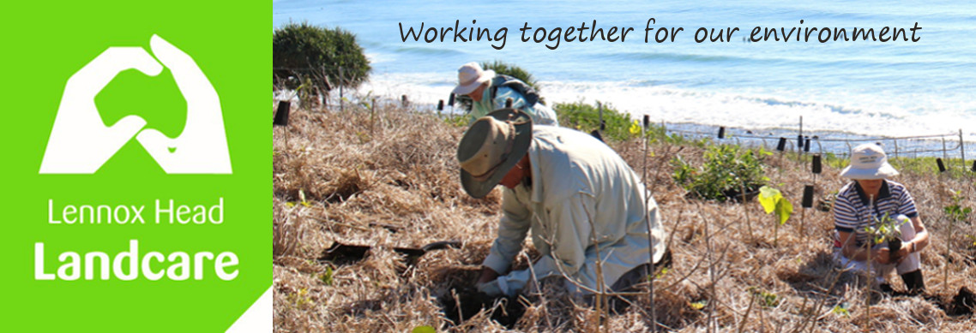

May 2022 Newsletter

Working Bees for June

Wednesday 1st: (8.30am) Seven Mile Dunes - opp. 53 Pacific Pde

Thursday 2nd : (8am) Skennars Head - Rocky Pt car park

Friday 3rd: (8am). Lake Ainsworth Water Hyacinth - car park opposite the surf club

Wednesday 8th: (8.30am) Boulders - Coast Rd car park

Thursday 9th : (8am) Skennars Head - Rocky Pt car park

Tuesday 14th: (7am) Bora Ring - 22 Gibbon St (check with Lindy for details)

Wednesday 15th: (8.30am) Kelly's dunes - car park opp surf club

Thursday 19th : (8am) Skennars Head - Rocky Pt car park

Friday 20th: (8am). Lake Ainsworth Water Hyacinth - car park opposite the surf club

Wednesday 22nd: (8.30am) Boulders - Coast Rd car park

Thursday 23rd : (8am) Skennars Head - Rocky Pt car park

Wednesday 29th: (8.30am) Bora Ring - 22 Gibbon St

Shaun
0448 221 210
