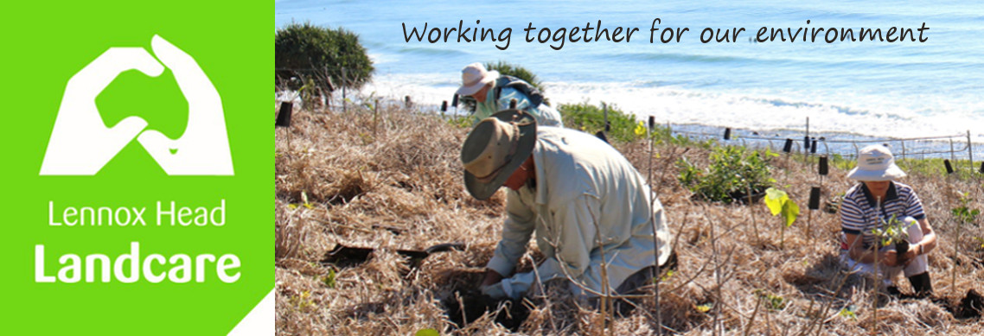

February Newsletter

Two Council Issues

Last newsletter I let you know about the Biodiversity Strategy. Our biggest concern is that if Council wait for grant opportunities to become available as their funding source, this could join the queue of other good plans that have taken 25 or more years to be put into action. Please, if you haven't already, either make a submission or complete the survey at: https://www.yoursayballina.com.au/
before March 17

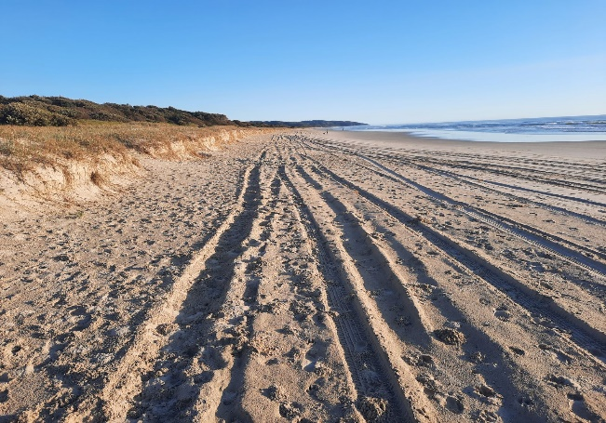
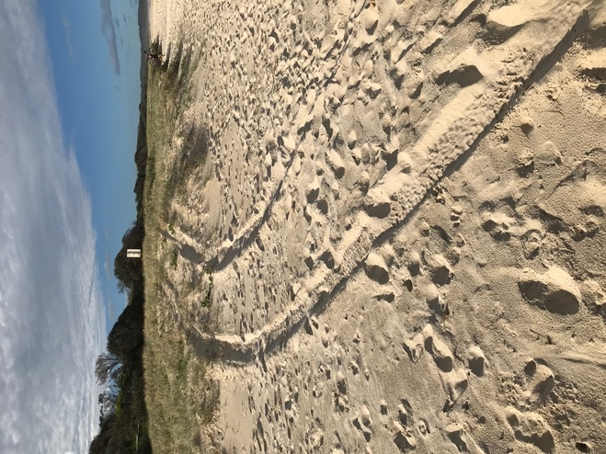

Since the last newsletter we have learned that Council's proposal for managing 4WDs on Seven Mile beach is also on public exhibition. According to Council staff there were an average 50 vehicles on the beach on each Saturday and again on each Sunday in the 2021/2022 FY, regardless of time of year. We disagree with Council that there is only occasional concern for pedestrian safety, based on the regular experiences of our members who walk the beach. We are also concerned that the staff report Councillors rely on, gave only passing mention t to known and potential environmental concerns, particularly since the beach is part of what is known as the Ballina Coastal Reserve, formed in 2004 with the declared purpose of "public, recreational and environmental protection ".

Here is what a resident who used South Ballina beach had to say before it was closed to vehicles.
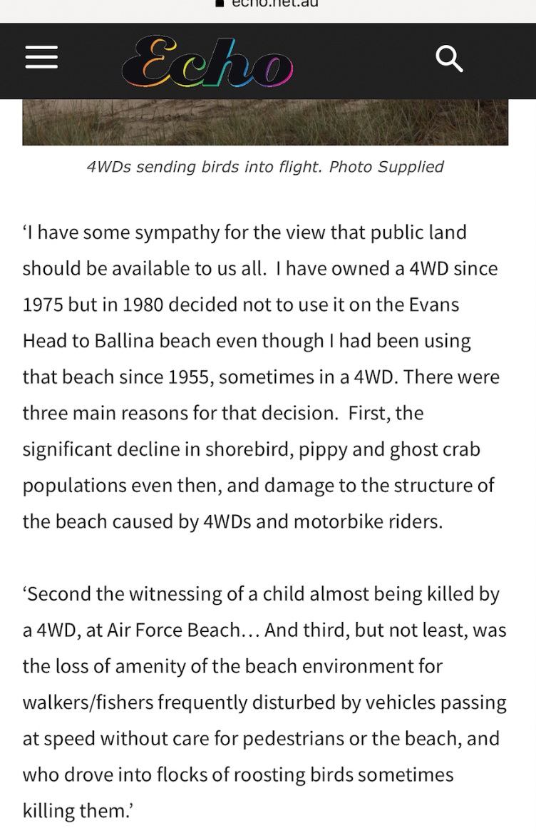

If you wish to have a say about this issue you have until March 8, also at: https://www.yoursayballina.com.au/

'Merch' for Lennox Head Landcare

The February Committee meeting decided to investigate sourcing baseball caps similar to the one shown below for members to purchase at cost and be able to wear as casual gear around town. A number of our members have been keen to get this happening for a while now... stay posted!!

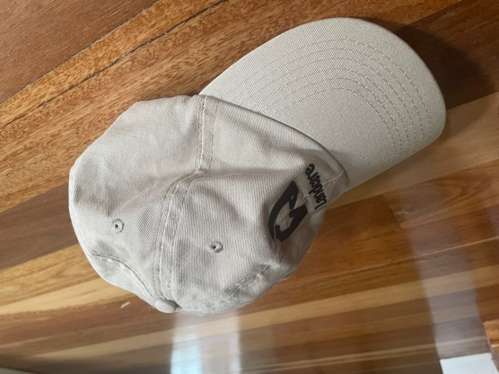
Landcare Plant Stalls

There are also promising signs that we will be able to start these up again this year, providing local natives for the gardens of our local community and building connections with each other. We may even be able to operate cashless for those that don't always have some spare cash in their swimmers! More info as we learn more...

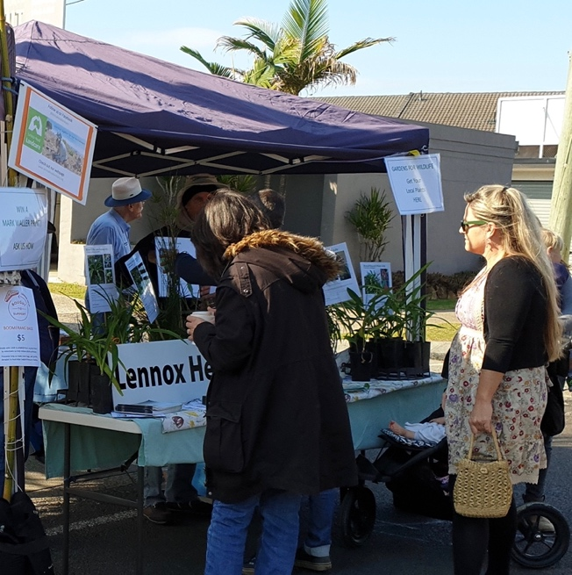

Working Bees for March

Wednesday 1st: (8am) Kelly's site - car park opposite the surfclub

Thursday 2nd : (8am) Skennars Head - Rocky Pt car park

Tuesday 7th: (8am ) Lake Ainsworth Water Hyacinth - car park opposite the surf club

Wednesday 8th: 80am) Boulders - Coast Rd car park

Thursday 9th : (8am) Skennars Head - Rocky Pt car park

Wednesday 15th: (8am) Shorty's Stairs - surfer's car park, Coast Rd

Thursday 16th : (8am) Skennars Head - Rocky Pt car park

Tuesday 21st : (8am). Lake Ainsworth Water Hyacinth - car park opposite the surf club

Wednesday 22nd: (8.30am) Boulders - Coast Rd car park

Thursday 23rd : (8am) Skennars Head - Rocky Pt car park

Wednesday 29th: (8.30am) Shorty's Stairs -surfer's car park, Coast Rd

Thursday 30th : (8am) Skennars Head - Rocky Pt car park

Shaun
0448 221 210

