Email not displaying correctly? View it in your browser.
July 2018 NEWSLETTER

 | 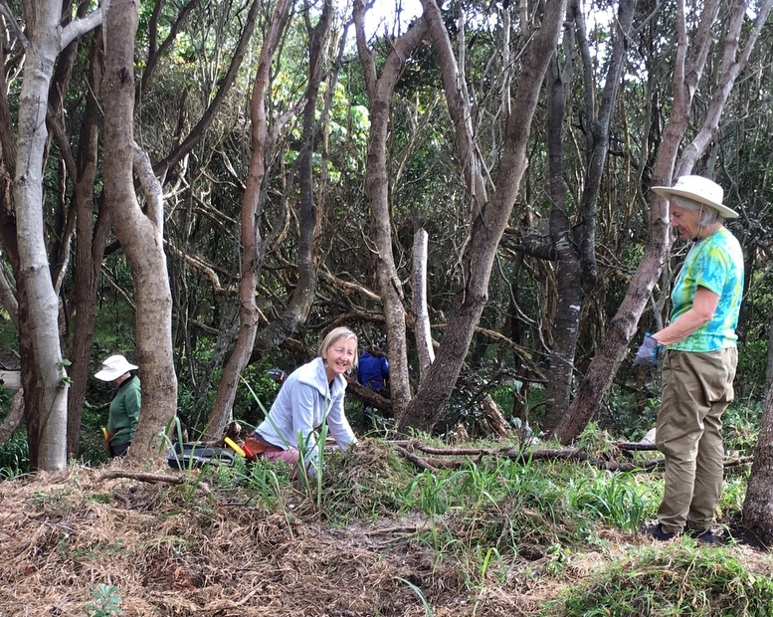  Well July was certainly a lot sunnier than June! The Wednesday crew managed to knock back an impressive amount of Durban Grass that has been encroaching onto the dunes near the toilet block at the dog walkers’ car park this month. They also continued planting more Dianella to replace it. Durban Grass (that’s the grass used in some Macadamia plantations to reduce soil erosion) is also called smother grass and that is exactly what it is doing wherever it gets onto the dunes.  At Boulder Beach cages are often used to protect young trees and bushes from wallabies which love to chew their tender bark. Over the last 3 or 4 years hundreds of trees have been planted and protected in this way. July turned out to be the month we freed many of these plants from their cages. It’s amazing how each plant seems to spring out and spread its branches when it's released and the entire area usually looks really well established once the cages are gone. It is such a wonderful reward for the hours of maintenance that have gone into getting the plants this far.  We also did some more work at the Lower Point, moving a thicket of lantana in preparation for planting, tackling a particularly large and nasty box thorn, dealing with some weedy vines and spreading more pig face along the eastern side of the shared path in front of Quarterdeck.  Every Wednesday is now celebrated with morning tea afterwards even when we aren’t working down in town so you can always find us at William St Kitchen about 30 mins after working bees finish up. Why not call in for a chat … ?  Conservation Volunteers Australia  With staff now based in Ballina, CVA have been establishing working partnerships with a variety of environmental groups in the Shire. In our case there are a few opportunities at the moment. One of these is a grant for 7 years which would include works to assist restoring the rainforest at Boulder Beach. This would be really helpful, especially in managing the exotic grasses which compete fiercely with plantings there. We look forward to working with this team as their plans develop.  Yours in caring for our natural spaces  Shaun  0448 221 210 |  | Upcoming Events  _____________  Quarterly meeting and AGM  Club Lennox 7pm  Monday August 27  ______________  August Working Bees  8.30 - 10.30 am  Wed 1st: Seven Mile dunes - north of surf club  Wed 8th: Boulders Beach - Coast Rd car park  Wed 15th Seven Mile dunes - opp. William St  Wed 22nd: Boulder Beach - Coast Rd car park  Wed 29th: Lake Ainsworth - SW corner  _______________  Skennars Head Working Bees  Every 2nd Thursday  Contact Pat Cawley on 6687 7143  Lower Point Working Bees  Organised as needed  Contact Mike Heesom through lennoxheadlandcare@gmail.com  _____________

Membership. $10 pa  BSB: 062502  Acc’t : 10183839  Acc’t Name: Lennox Head Landcare |  | Subscription  Update Email Address  Unsubscribe |  | Share  Facebook  Twitter  Forward to a Friend

Rather not receive this newsletter anymore? Unsubscribe

This email is powered by Direct Mail for Mac. Learn More • Report Spam

