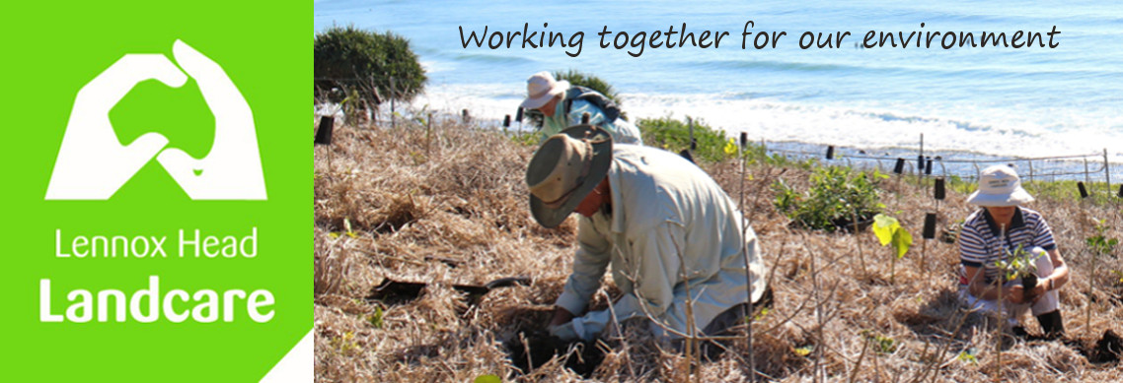

November Newsletter

Xmas BBQ

Sunday Dec 11 5.30

South Western BBQ area at the lake
(western end of the southern foreshore)

you bring
a plate to share
chair/s
tour preferred beverage
cutlery etc

we provide
tables
beef sausages and pork sausages / veg patties maybe / haloumi
BBQ tools
bread

We'd love to share a relaxing time relax and share time with you if you can make it

Please RSVP by Friday Dec 9 to help the shoppers out.

Summer Break for Wednesday Crew

The Wednesday crew take a break over summer. The last working bee will be the second Wednesday in December and resume in February. There will be a newsletter at the end of January with info re the February bees. For those that wish to continue the Skennars Head team and the water weed team will continue as usual. Malcolm and I will probably be doing bits and pieces at Boulders and William St as well and would welcome any offers of assistance. Get in touch with me for further info on this if you are interested. will be and I'm sure Malcolm would welcome some assistance at Boulders as well. Happy summer everyone.

Rob Seal's Memorial gathering

Well the skies opened overnight so we deferred the tree planting and decamped to an inside venue for the memorial. Every speaker talked about Rob's warmth, his generosity and his love for all things nature. Kelly spoke on behalf of we landcarers and talked about his mentoring of her adventures into bird photography. Robyn shared her belief that Rob would have loved to see the synergy between the groups of birders and landcarers.. Synergy there definitely was and some of the conversations opened up possibilities for future shared excursions.

Stay tuned for news about the tree planting some time down the track..

Vic Faulkner's Memorial

A small group of landcarers joined the Anglican congregation and Vic's family for this service. We heard about Vic's early life in Corndale and then Rifle Range Rd, followed by his life in Papua New Guinea and his passion for "fixing" stuff even if it meant dismantling an engine in the lounge room.
We heard about his move to Lennox Head in the 1970's when he and his family returned to Australia and his strong connection to family and to Crawford house in Alstonville.

Working Bees for Dec - Jan

Wednesday Dec 7 : (8am) Kelly's site - car park opp. the surf club

Thursday Dec 8 : (8am) Skennars Head - Rocky Pt car park

Thursday Dec 8. : (8am). Lake Ainsworth Water Hyacinth - car park opposite the surf club

Wednesday Dec 14 : (8am) Boulders - Coast Rd car park

Thursday Dec 15 : (8am) Skennars Head - Rocky Pt car park

Thursday Dec 22 : (8am) Skennars Head - Rocky Pt car park

Thursday Dec 22. : (8am). Lake Ainsworth Water Hyacinth - car park opposite the surf club

Thursday Dec 29: (8am) Skennars Head - Rocky Pt car park

Thursday Jan 5 : (8am) Skennars Head - Rocky Pt car park

Thursday Jan 5. : (8am). Lake Ainsworth Water Hyacinth - car park opposite the surf club

Thursday Jan 12: (8am) Skennars Head - Rocky Pt car park

Thursday Jan 19 : (8am) Skennars Head - Rocky Pt car park

Thursday Jan 19. : (8am). Lake Ainsworth Water Hyacinth - car park opposite the surf club

Thursday Jan 26 : (8am) Skennars Head - Rocky Pt car park

Have a wonderful Xmas, New Year all!

Shaun
0448 221 210

