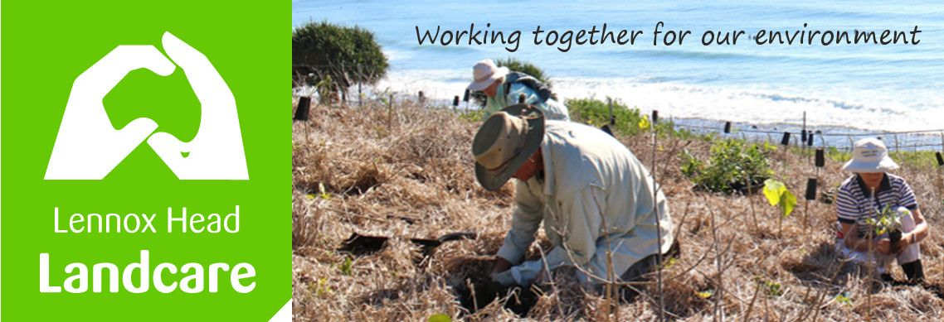

Lennox Head Landcare Quarterly Meeting

Monday 22nd February 2021

Sanctuary Village

Attendance: Malcolm Milner, Warren Taylor, Pat Cawley, Shaun Eastment, John Hutton, Mike Heesom, Martin Gorin, Barbara Sparrow, Kelly Saunderson (by phone)

Apologies: Sue Williams, Angela Bergin, Linda Hill
Visitors:

Minutes of previous Meeting Held on 30th November 2020
Minutes were accepted as a true record.
Moved: Mike. Seconded: Malcolm

Matters Arising

- Ballina Coastal Reserve Management Plan review:
The review of this is currently underway. Malcolm raised the issue of the impact of sand mining at Boulder Beach and it was suggested that he write to BSC requesting it be included in the scope of the review. BSC has not yet responded. Malcolm

- Lighting for Wildlife, Dogs off-leash from Pat Morton to Sharpes and wildlife corridors:
So far we have heard nothing further. Shaun will present questions with notice at the upcoming B Ward committee meeting assisted by Mike. Moved Shaun, Seconded Mike

Reports
Treasurer:
For three months to September.
Please see the attached report.
$1168.29 income (plant sales going well), $452.66 expenses. Cash Balance $5879.97
Report accepted: Shaun, Warren

Skennars Head:
All very well. Some BSC funding for weeding the coast side of the track may be coming. Watervine is presenting a problem.
Iron peg parking area is to be resurfaced.
Lower Point site:
2 working bees, week 3 and 5 of March at Pinnacle Row. Cultural burning is being planned to encourage the themeda grassland on the Headland.
Darren Baily and Ross Faithfull are doing bush regen work on the area to the north and the south of the Shorty's Stairs revegetation.
Coastal Advisory meetings will be coming back. Mike

Lake Ainsworth Water Weeds:
Regular monthly hyacinth sessions have been very effective. Some specialty planting to control unwanted access along the eastern Lake foreshore will be done. Kelly.
BSC B ward meeting:
There has not been one. Mike’s response, on behalf of The National Surfing Reserve, the Residents' Association and Landcare, with concerns regarding a putative surf event was appreciated by Council.

General Business

Malcolm: Has had a lot of problems in the area which was occupied by the sand mining plant in the 1950's.. Many many plants have died. Soil samples show very poor soil by agricultural standards, especially high Aluminium. Malcolm has done a lot of experimental work and produced a comprehensive report. On this basis he has asked council to commission a professional investigation into on the geochemical/geomorphological status of the site and propose a management strategy to revegetate the area successfully. An experimental plant is being used to check various interventions.
Council would need to get a substantial grant to proceed effectively.

UNE is researching the current status of grant funding for environmental works. This will potentially be used to inform future grant programs so it is important that community groups such as ours respond.
Shaun will complete the survey on our behalf.

New Business

Uni Wollongong is conducting a survey info on exotic grasses and their impact on native vegetation. Shaun to make this available to Kelly, Malcolm and Mike.

Correspondence

In: B Ward Committee minutes
BSC - response to request for planning process and timelines on 3 issues
Landcare NSW - survey by UNE re funding for community environmental works
BSC - offer of Weeds Calendars
Uni of Wollongong - survey on exotic grasses.
Richmond landcare Inc.- response to request re possible grants for Boulders.

Out: Richmond Landcare Inc - request for advice re grants suitable for rehabilitation of
sandmining site at Boulders

Meeting closed: 2026 hours
Next meeting: Monday, 31st May 2021, 1900hours, Sanctuary Village.

