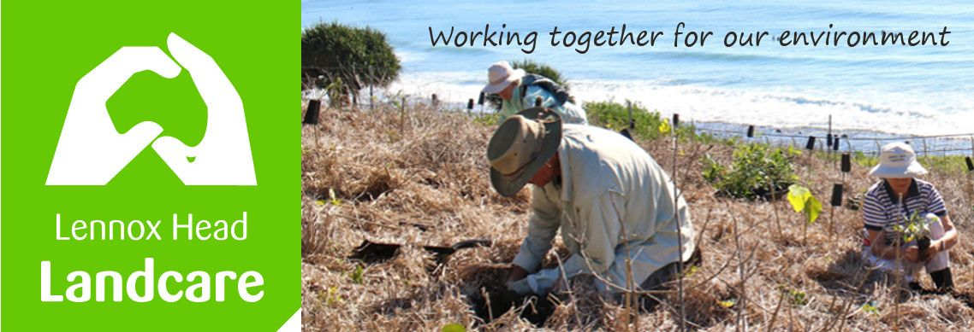

Lennox Head Landcare Quarterly Meeting

Monday 24th February 201

Sanctuary Village

Attendance: Malcolm Milner, Warren Taylor, Shaun Eastment, Sue Williams, Angela Beglin, Kelly Saunderson, John Hutton, Mike Heesom

Apologies: Barbara Sparrow, Pat Cawley, Martin Gorin
Visitors:

Minutes of previous Meeting Held on 25th November 2019
Minutes were accepted as a true record with amendments to the Treasurers Report as discussed.
Moved: Shaun. Seconded: Sue

Matters Arising

Work site “before and afters”: These will be loaded to our website as Warren receives them.

Action: Shaun to forward photos to Warren

The community weeds project has had it's first spray through. Some follow up still to be completed on the glory lily at Seven Mile. Invitations for a bus trip bus trip to tour the sites from the border to the south of us (March 18) will be sent out sometime soon for those interested.

Our Constitution was considered. The following minor changes to our procedures were agreed to in order to better meet our Constitution:

- new members will be circulated to the committee. If no concerns are raised the membership will be confirmed by email.
- The date of joining for each member will be recorded (in the Gmail contacts database from now on if possible, alternatively it is in the receipt book archives).

As well, the meeting confirmed that:
- committee positions will be filled from the meeting floor at each AGM unless written nominations have been received by the secretary in line with constitutional requirements.
- the secretary will be responsible for ensuring he/she is able to produce a written record of membership details if requested.
- membership payments received after the 1st July each year constitute membership for that financial year.

Action: Sue to keep committee informed of new members, Warren to check he can produce the required membership info if requested.

The final draft of the Lake Ainsworth Coastal Management Plan has been prepared for approval by Councillors. Once approved it is then sent to the relevant State Dep't for gazettal at which time it becomes a statutory document.
The Coastal Advisory Committee will be meeting tomorrow and we discussed issues to be raised.

Malcolm is seeking funding for further soil analyses from Council

Reports
Treasurer:
For 6 months to 31st December
Incoming funds $973.67. Plant sales garnered $246.00
Expenses were $903.25.
Balance is $5467.34.
We still have $237.44 of the Richmond Landcare grant to spend.
Report accepted: Sue, Kelly,
Skennars Head:
No report

Lower Point site:
More Birdwing Butterfly vine will be planted.
around 600 - 800 plants have gone in at the Pinnacle Row site during the Jan/Feb rains and are going gangbusters. But so are the weeds.
Lake Ainsworth Water Weeds:
So far a slow year for the Water Hyacinth, possibly because the seed bank has been stranded whilst the lake levels were low. Now that the lake is fuller again the Hyacinth may become more of a problem.

General Business

Feedback from BSC meetings:
Shaun raised the problem of the inadequate maintenance of the turf cell carpark and gardens next to the Caravan Park, pointing out that Council installed these knowing that watering and, in the case of the turfcell, regular reseeding would be required on an ongoing basis. Access to water has not been provided despite requests from FOLA who are prepared to maintain the gardens. This needs to be attended to as a priority.

Lake Ainsworth SE Precinct: It was agreed that the riparian plantings along the lake foreshore would be carried out by regular working bees to better protect existing plants.

Action: Kelly to organise plantings, Shaun to confirm plants needed and availability with Council nursery

Shaun and Kelly have been talking about ways to involve the general public more in our local environment. Kelly raised the possibility of a basket weaving workshop at the Lake. Concerns were raised about the potential for damage to lake vegetation if people started foraging for basket weaving materials.
Any further ideas on raising public engagement will be most welcome.

Action: Kelly to investigate further and bring a more detailed proposal to a meeting

Love Lennox is the second Saturday in June, the 13th.

New Business
BSC nursery have 200 Birdwing Butterfly vines close to maturity.

Action: Spider to confer with James B re how to distribute these/ who to etc.

Lack of progress on the cycleway from the creek up to Pat Morten Lookout is preventing us doing work. We were anticipating access form the Coast Rd around October 2019. Recent rains have washed away some of the crushed shale from the track they are building up to the Pat Moreton carpark.

Action: Malcolm to contact Paul Busmanis re organising access to Boulders from the Coast Rd before the track is completed, Shaun to follow up with James B and possibly Councillors if needed.

Correspondence

In: Love Lennox for 2020
Invite to Ballina Coastcare 30th anniversary
Guidelines for FNPWS grant
BSC support for FNPWS grant

Out: Application for FNPWS grant
RSVP for Ballina Coastcare 30th Anniversary

Meeting closed: 8.34pm

Next meeting: Monday, 18th May 2020, Sanctuary Village.

