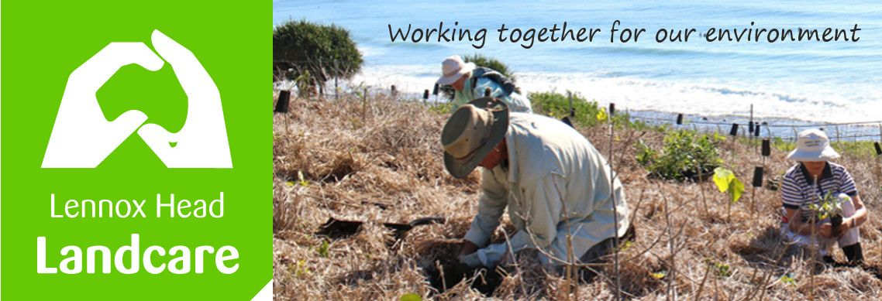

Lennox Head Landcare Quarterly Meeting

Monday 24th August 2020

Sanctuary Village

Attendance: Malcolm Milner, Warren Taylor, Pat Cawley, Shaun Eastment, Sue Williams, Angela Beglin, Kelly Saunderson, John Hutton, Mike Heesom, Martin Gorin, Barbara Sparrow, Linda Hill

Apologies:
Visitors:

Minutes of previous Meeting Held on 24th February 2020
Minutes were accepted as a true record with amendments to the Treasurers Report as discussed. Notes for a Zoom meeting May 18 2020 were also considered
Moved: Shaun. Seconded: Sue

Matters Arising

Angela and Kelly have been talking about ways to involve the general public more in our local environment.
Some ideas are still being investigated.
Any further ideas on raising public engagement will be most welcome.

Action: Kelly and Angela to investigate further and bring a more detailed proposal to a meeting

Reports
Treasurer:
For the financial year
Please see the attached report. 30 June 2020
$6581.87 income, $6344.23 expenses. Cash Balance $4870.69
We still have $237.44 of the Richmond Landcare grant to spend.
Report accepted: Sue, Kelly

It was resolved to continue to use the Zero accounting software until otherwise decided. A Beglin, M Heesom
Skennars Head:
A grant to acquire a whippersnapper has brought great happiness. Bushland Services have taken out the asparagus and other weeds making maintenance much easier.
No mountain bikers or other malign influences lately. The pandanus are self seeding remarkably well this year.

Lower Point site:
About 2000 plants have gone in this year. Some old fencing has been removed and new installed as further areas are regenerated. The newly released vegetation management plan is being referenced.
Great progress is being made and the area is a showcase.

Lake Ainsworth Water Weeds:
The hyacinth disposal to compost has been challenging due to Covid. The weed has been very fecund as has the Salvinia. A continuing problem kept at bay by some dedicated members.

General Business

Feedback from BSC meetings: Many items discussed above.

Lake Ainsworth SE Precinct: The ”Vegetation Management Plan Lennox Head (Coastal)” has finally been published and will be a bible. It is an extensive and very useful document.
It is the definitive document guiding activities on Council managed land in the area.

New Business

Richmond Landcare helps to organise the Science Hub with many presentations of interest to us and engender interest in Science in the general population. We have sent some ideas for collaboration.

We prefer to keep the current working bee hours of 8am summer start and 8.30 winter.

Local Fontainea plantings on 24 local sites (4 ours) are going very well. A successful regional project.

The website has been brushed up. Take a look.

Malcolm is after more advice on how to remediate Boulders and considering approaching SCU re student investigation into the site. Particularly after the mining it is not natural soil and may not allow growth. Hydrological changes due to ongoing Council works do not help.
The Coastal Advisory group may be able to help.

Correspondence

In: 3 new requests to attend working bees
Weebly re website renewal
Request for personal details of site managers for Sci license appln on behalf of BSC
Acknowledgment of submission re 4WD use of 7 Mile beach
Acknowledgment of submission re Lennox Vision
Query from Spec Ed at BCH re joining working bees
Advice re successful Community Donations grant
Response from Horizen 5 for species list for regen plantings at Aureus
Coastal Fontainea media release from DPIE
Request to host school visit by year 9 Earth and Environmental students from Trinity College Lismore

Out: Details re site managers for BSC Sci license application
Submission re 4WD on 7 Mile
Submission re concept plans for public exhibition for LVV
Response to BCH
Request to Horizen 5 for species list for regen plantings at Aureus

Meeting closed: 8.34pm

Next meeting: Monday, 30th November 2020, Sanctuary Village.

