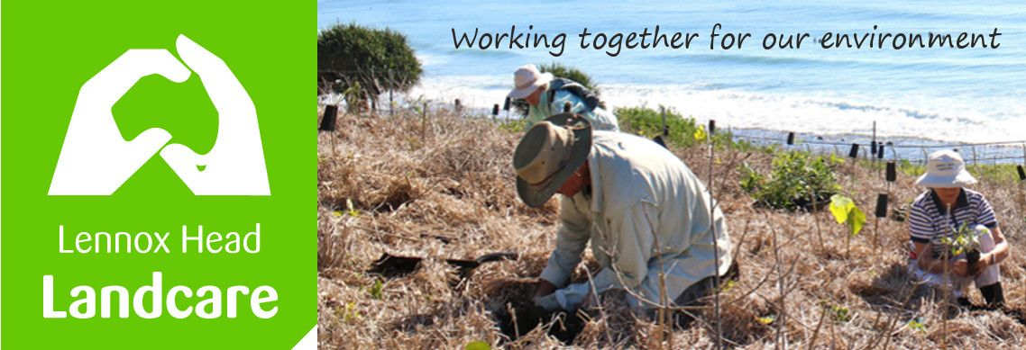

Lennox Head Landcare Quarterly Meeting

Monday 14th March 2022

Sanctuary Village

Attendance: Malcolm Milner, Warren Taylor, Pat Cawley, Shaun Eastment, Kelly Saunderson, John Hutton, Barbara Sparrow, Angela Beglin, Lou Miller

Apologies: Sue Williams, Mike Heesom, John Hollingsworth

Visitors: Nil

Minutes of previous Meeting Held on 30th November 2021
Minutes were accepted as a true record.
Moved: Pat Seconded: Malcolm

Matters Arising

- Field trip to Boulders associated with NSW Landcare conference - cancelled as Covid has caused conference to move on-line.
- Nursery Plans – Community Gardens are, informally, interested insharing their site with us but Council must sign off.
Reports
Treasurer:
For details three months to February please see the attached report.
overall - $250 income, $108 expenses. Current cash balance $5789.
We have 36 financial members.
It is time to stocktake our equipment.

Report accepted:
Moved: Angela Seconded: Warren

Skennars Head:
The wet has not caused too much trouble. A banksia and a few other plants fared badly. It is looking very good and mature. More plants, 25, to go in.
Lower Point site:
No report this quarter but it is looking very good.
Lake Ainsworth Water Weeds:
An extraordinary amount of water is in the Lake. No surprise. The BBQs are still under water. We will inventory damage to our plantings and review species mix.
Hyacinth has been doing well too unfortunately; we may have a working bee in the near future

General Business

- Review of Lennox Head Community Aspirations Strategic Plan

State govt has ultimate control via the Planning Act then there are 3 levels of planning instrument at Council level. In order of decreasing power to define development and other aspects of town planning these are:
1.Business Control Plan
2. Local Environmental Plan
3. Community Aspirations Strategic Plan

Lennox Head Landcare needs to be loud in the Community Aspirations Strategic Plan which was last reviewed in 2002.
We closely read the document with the view of modifying it as our submission to Council. Stronger more declarative language is need. An emphasis on improving the natural environment rather than just preservation is favoured.
A group will convene to draw up more specific guidelines for LHHC to amend/approve. This will then inform all submissions to BSC on the LH(Community Aspirations) Strategic Plan review. Public exhibition of the draft is due in May unless deferred due to flood recovery interruptions.

Action: Shaun to forward the slides on the Environment to all members to provide feedback on what we want into the future.

- Other Issues to pursue with BSC in 2022

Our priorities for 2022 will be:

Wildlife Corridors
Malcolm and Warren are delegated the responsibility to pursue the subject of wildlife corridors on our behalf.
Moved Shaun. Seconded: Kelly

Dogs and Vehicles on Seven Mile
Spider is delegated the responsibility of pursuing the issue of dogs off-leash / vehicles on Seven Mile Beach with BSC on our behalf.
Moved: Shaun. Seconded: John H
Designated Wildlife habitat / protection zones
Shaun is delegated the responsibility of pursuing the issue of wildlife habitat/protection zones with BSC on our behalf. This could encompass features such as dark sky zones and interpretive/educational signage
Moved: Shaun. Seconded : Malcolm

Degradation of land at the northern end of Sharpes
Pat is delegated to pursue restoration of eroded land with BSC on our behalf.
Moved: Shaun. Seconded: Barbara

Shaun and Kelly will start the process by meeting with each of the B Ward Councillors to outline our priorities and sound out their possible position on each.

Correspondence

In: Insurance - docs for completion
Website contacts - 2 enquiries re joining working bees
- 1 enquiry re providing cane toad control at a private residence
- 1 enquiry re providing generic native plants for gardens
LLS - planning for Boulders Field Day
BSC - B Ward minutes for November 21
BSC - invite to participate in Ballina Strategic Plan workshop
Tuckombil Landcare - request to share our Constitution
BSC - modifications to North Lennox Firetrails
RLI - request to share Constitution with Wilsons Nature Reserve Landcare

Out: responses to website enquiries
acceptance for BSC SP workshop / Mike H to attend
copy of our Constitution provided to Tuckombil Landcare and Wilsons Nature Reserve Landcare.

Meeting closed: 2055
Next meeting: Monday, 27th May 2022, 1900hours, Sanctuary Village.

