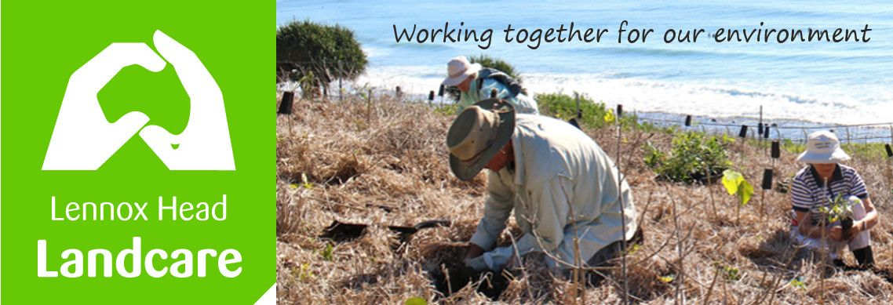

Lennox Head Landcare Quarterly Meeting

Monday 30th August 2021 1930hrs

via Zoom

Attendance: Malcolm Milner, Warren Taylor, Shaun Eastment, Sue Williams, Mike Heesom, Barbara Sparrow, Kelly Saunderson, Angela Beglin, Rob Seal, Jan Gough-Watson

Apologies: Pat Crawley, Ian Forster, John Hill

Visitors:

Minutes of previous Meeting Held on 31st May 2021
Minutes were accepted as a true record.
Moved: Malcolm Seconded: Angela

Matters Arising

- Lighting for Wildlife,: BSC has settled on at lighting options meeting National light standards for the village centre and Essential Energy is involved. We will continue to pursue Council for a more detail. Shaun

- Ballina Coastal Reserve Management Plan review: we are still waiting for the public consultation on the use of 4WDs on Seven Mile beach. Meanwhile Council have resolved to investigate the use of a rego recognition camera placed at a boom gate providing access to the beach.

- Dogs off-leash between Pat Morton and Sharpes. BSC has upped the ranger presence and renewed signage. We have not seen any better obedience. We have suggested the area be made a wildlife habitat. Another possibility would be to monitor and report results to council ourselves; Shaun will discuss acceptable strategies with James.
Malcolm and Shaun

- Boulders soil. SCU have run out of options. Meantime James B is still intending to auger a grid of samples to 2m deep to finally determine both the nature of the problem and its boundaries. As well, Malcolm has sourced a fungal additive. He also reports that the addition of Gypsum appears to have encouraged some grasses and discouraged the native couch that was there.

- Website planning. Kelly proposed a simpler way to add our Plants for Backyard Habitat. Kelly, Shaun and Warren will tackle this.

Reports
Treasurer:
we made a profit of over $300 last quarter.

Motion: That the signature at the CBA, Ballina will be changed from Sue Williams to Angela Begiln.

Moved ; Sue Williams Seconded: Mike Heesom
Passed unanimously.
Report accepted: Shaun, Jan

Skennars Head:
Not much is happening at the Skennars site at present. We have 8 small pandanus seedlings to plant in the grove at south end of the car park. James has had one of his teams clean out the eastern side of the walking track from Boulder to Sharpes and we will follow up there once we resume work. We have begun working at the southern end of the Sharpes Beach car park-prior to our weekly debriefing at the Cafe de Wheels- and James had a large pile of garbage removed.
I still think that there should be some informative signage at both ends of the track regarding dogs off leash and reminders to bike riders to sound a bell before passing pedestrians. Pat.
Lower Point site:
More lantana clearing and work near the offset section to link up with it. I suggest we do a Wave article in the next few months on the work on this site since the Coastal Track has had so much foot traffic recently. We can acknowledge John Hill respectfully in the article. I also suggest that we hold another working bee there this year, in the area in front of Jan's place. Spider to provide Jan with a list of approved species for the area.
Mike
Lake Ainsworth Water Weeds:
Pete is doing an amazing job monitoring the hyacinths seasonal comeback. We will a big effort in a month or so. Covid has caused a pile up of drying Hyacinth near the boat shed @ Sport & Rec. Kelly will work on a solution for this. Kelly
BSC News:
There has not been much activity in either B Ward or Coastal Advisory over the last 3 months.

General Business

- Shaun with Sue, Malcolm and Spider and Pat, has developed a timeline and descriptions of work done by Lennox Head Landcare. The Heritage Committee requested this information for the Centenary and it was helpful in providing info for the National landcare nomination made by RLI as well. Background stories on Boulders, Skennars and the Lower Point to come. Lovely work. All agreed it would be a great addition to the website together with the gallery of before and afters. Malcolm volunteered a photo of the old toilet block at the Lower Point and Spider volunteered to get a current shot from the same perspective to add to the website.

- The nursery needs to be moved from Shaun’s backyard. The North Coast Community Forum has grants for which this would be suitable. A location and design will be investigated over the next year. Malcolm suggested the wetlands at Epiq could be a suitable site. Shaun to follow up on this with James B. Shaun

New Business

The state Landcare Conference is at Tweed next March. They have asked if Boulders can be an excursion for them. 2 buses worth. Malcolm is organising this. We will all help.

Kelly would like to purchase water crystals. It would appear that the times of rain will be shortened under Climate Change modelling so the crystals would help provide resilience to new plantings. Shaun and Spider to investigate the generous Bunnings would help.

We are planning to use knowledgeable members to lead ecological tours of our local area? We could develop booklets on our birds and plants. The meeting agreed that Kelly, Rob and Spider could scope a publication out and find someone to put it together. Kelly will seek out a suitable grant to cover costs.

Correspondence

In: BSC - Coastal Advisory meeting June
Water NR Alliance - request for submissions re Dunoon Dam
Weebly - payment due
L. Kerr - use of BB as Conference site visit
D. Addendorff - intending to return when Covid sorted

Out: BSC - plantings on road reserve Pacific Pde
BSC - party site and rubbish dump in the heath
Membership - public exhibition of BSC draft Climate Action Policy
BSC Crs - Lions Shed on LH Community Gardens site
Membership - survey re traffic calming measures downtown
Membership - vacancy for Treasurer 2021/22

Meeting closed: 2045 hours
Next meeting: Monday, 29th November 2021, 1900hours, Sanctuary Village.

These minutes are a true and accurate record of the meeting

signed: signed:

name: Shaun Eastment name: Warren Taylor

position: President position: Secretary

