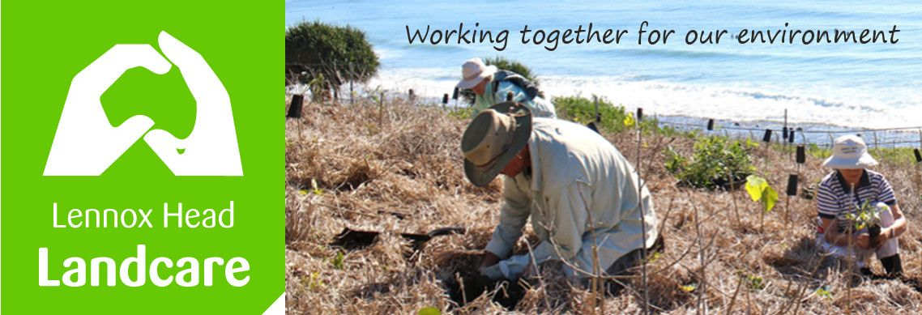

Lennox Head Landcare Quarterly Meeting

Monday 30th November 2020

Sanctuary Village

Attendance: Malcolm Milner, Warren Taylor, Pat Cawley, Shaun Eastment, Sue Williams, Kelly Saunderson, John Hutton, Mike Heesom, Martin Gorin, Barbara Sparrow, Angela Bergin

Apologies:
Visitors:

Minutes of previous Meeting Held on 24th August 2020
Minutes were accepted as a true record.
Moved: Sue. Seconded: Malcolm

Matters Arising

- Ballina Coastal Reserve Management Plan review (4WDs on SMB) :
The review of this is currently underway. Public consultation was planned to occur before Xmas but is delayed. The review is due for completion in June 2021 - we have requested a revised timeline from BSC be forwarded before Xmas. Malcolm raised the issue of the impact of sand mining at Boulder Beach and it was suggested that he write to BSC requesting it be included in the scope of the review
- Lighting for Wildlife: Our request that the National Guidelines be incorporated in BCS policy for all lighting in Lennox Head has resulted in BSC contacting Essential Energy re this. So far we have heard nothing further. The next step to this goal will be us writing to Council to an update on the progress. Moved Shaun, Seconded Malcolm

- Dogs off-leash Pat Morton to Sharpes:
These areas are not off leash areas but are being treated as such by increasing numbers of walkers. This stretch has specifically been rehabilitated over many years to provide wildlife habitat and there is disturbing evidence of off-leash dogs harassing wildlife. We are pushing Council to take action to address this (signage, education, increased ranger presence etc) BEFORE the culture becomes entrenched as it has at Angels Beach. At this point all we have heard from BSC are statistics on dog attacks on people across the Shire. The meeting agreed that Shaun should continue to press this issue with BSC highlighting the impact on wildlife as opposed to people. Moved: Shaun, Seconded: Barbara

Reports
Treasurer:
For three months to September.
Please see the attached report.
$1273.85 income, $598.52 expenses. Cash Balance $5276.36
We still have $44.59 of the Richmond Landcare grant to spend.
Report accepted: Sue, Kelly

Skennars Head:
The whippersnipper has been running hot so Pat is spending some money. A grant has covered this so far but we will need to pay for consumables, say $120pa. Resolved to do so. Moved: Sue Seconded: Angela
Lower Point site:
Spider has been clearing even more. 200 plants will be in soon. Watering is a bit of a problem.
Replanting up near the stairs and other top open areas is under consideration. There is a lot of salt and wind shear. The hanggliders also launch from the area and hence Council has to keep an emergency landing space plus the take-off area free of high vegetation.
Council, with local contractors, will be planting under the lookout area where they have removed vegetation recently.
Lake Ainsworth Water Weeds:
Regular bees, second Monday of the month have begun. 7 last time. Council is looking after disposal (with some reminders). Kelly.
General Business

Xmas gathering is on Sunday 6th 1730 hours at the SW corner of the Lake. Watch for the newsletter and RSVP.

Ross St Planting: some locals are looking after a patch there with guidance.

LA parkland plantings – BSC have delayed the planned community planting, hosted by Residents' Assoc'n, until Feb/March 2021 which is the date we originally suggested woulkd be the most suitable.

Plant Stall – we have held it near the track at the end of the bream hole. Went well with over $200 raised and lots of plants for local gardens. An earlier stall near the Surf club raised $550 and provided contact with many newer residents.
Lennox Head Community Aspirations Strategic Plan input. Shaun was asked to give ideas in a pre-concept plan phase which will eventually be put out for public consultation. This plan guides Council planners but is not as enforceable as the DCP or LEP. Shaun outlined issues she tabled based on previous ideas discussed by LHLC. For example, more street trees, keep significant landscapes untouched, the inadequate area of land dedicated to keeping a clear natural division delineating Ballina from Lennox, no mention of aboriginal culture is to be found in Lennox.

Feedback from BSC meetings: Spider raised for discussion aboriginal culture is almost completely missing. Council has been discussing this with Jaly Aboriginal Land Council with a view to highlighting areas and acknowledging place names.
The Lake has begun to suffer from some nasty hooliganism and additional police patrols including at night are scheduled.
Water runoff near the Coastal/North Creek roundabout may result in reengineering; and it needs sprucing up. We hope to consult on planting.

New Business
Wildlife Corridors : Malcolm and Spider have both raised concerns about the adequacy of those which appear in current planning documents. Shaun has clarified with BSC that these are being revised in the Biodiversity Strategy (BS) currently being prepared by Council staff and requested that we be provided with a copy of the planned process for developing the BS and the anticipated timeline, including provision for public consultation.

The Bora Ring has been receiving lots of additional attention from a small team of our members.

The Coastal Track is nearly finished. Watch out for the mountain bikes.

Correspondence

In: BSC - Scientific Licence
BSC - notif'n of B Ward meeting
BSC - weed calendars
BSC- B Ward minutes

Out: Minutes AGM and August committee meeting - financial members
plant stall details - Sonja Baker
weed calendar offer - financial members
BSC - amendments to B Ward minutes.

Meeting closed: 2045
Next meeting: Monday, 22th February 2021, 1900hours, Sanctuary Village.

