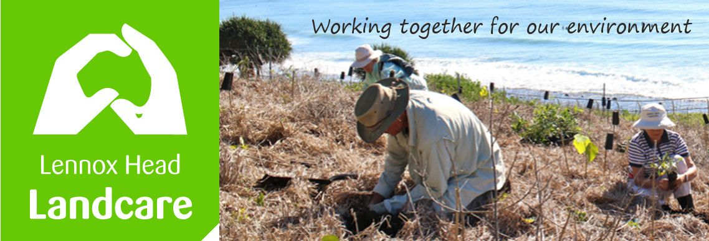

Lennox Head Landcare Quarterly Meeting

Monday 31st May 2021 1900hrs

Sanctuary Village

Attendance: Malcolm Milner, Warren Taylor, Pat Cawley, Shaun Eastment, John Hutton, Mike Heesom, Martin Gorin, Barbara Sparrow, Angela Bergin, Sue Williams

Apologies: Kelly Saunderson
Visitors:

Minutes of previous Meeting Held on 22nd February 2021
Minutes were accepted as a true record.
Moved: Malcolm Seconded: Pat

Matters Arising

- Lighting for Wildlife, BSC has settled on at lighting options meeting light and black sky standards for the village centre and Essential Energy is involved. We will continue to pursue Council for a general policy. Shaun

- Ballina Coastal Reserve Management Plan review:
- Dogs off-leash between Pat Morton and Sharpes. BSC have indicated they have ordered new signage for all entrances to the Coastal Rec Path. They say they will continue to educate the public and to monitor and enforce compliance. The meeting was not satisfied that the statements about education and compliance are sufficient and endorsed following this up with Councillors. There was agreement that we pursue having this declared and signed a “Wildlife Habitat Zone” from the boardwalk at Lennox to the North Wall and follow up with signage explaining why dogs on- leash are necessary / helpful.
Malcolm and Shaun

4wd on 7 Mile is under the coastal management plan. This is still being worked through.

Boulders soil. Malcolm is talking to SCU. They are thinking about what to do. James B has tendered out weed and replanting work in some areas. Extensive soil testing will be done.

Reports
Treasurer:
For 9 months to March.
Please see the attached report.
$2562.14 income (plant sales going well, bakery continues to send us money too), $1743.65 expenses. Cash Balance $5439.97
Report accepted: Shaun, Warren

Skennars Head:
All very well. Weeding along the Coast Road is going well.

Lower Point site:
James has 2 bush regen people cleaning up sections under the headland.
A new area has been prepared for planting.
Some of the Norfolk pines will be replaced. Mike

Lake Ainsworth Water Weeds:
It is still growing but Kelly is away so no report.
BSC B ward meeting:
Several items were discussed above. Ross Lane flooding is being studied.

General Business

Council has money to rehabilitate very degraded land. Whites Head is an example. If anyone knows of a spot let us know.

A vegetation management plan is in draft form. It covers all that is good for 16 patches of land around North Creek Rd including Tara Downs.

New Business

Pat is a certified hero, 20 years of work at Boulders. He will be in the next Wave. The meeting agreed to profile members regularly beginning with John Hill.

Correspondence

In: B Ward Committee minutes
BSC - response to request for planning process and timelines on 3 issues
Landcare NSW - survey by UNE re funding for community environmental works
BSC - offer of Weeds Calendars
Uni of Wollongong - survey on exotic grasses.
Richmond landcare Inc.- response to request re possible grants for Boulders.

Out: Richmond Landcare Inc - request for advice re grants suitable for rehabilitation of
sandmining site at Boulders

Meeting closed: 2015 hours
Next meeting: Monday, 30th August 2021, 1900hours, Sanctuary Village.

