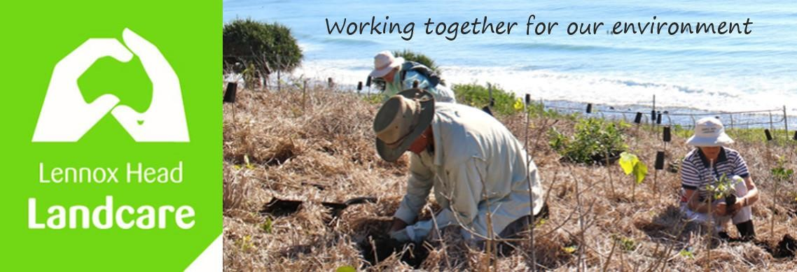

Committee Meeting 26th February 2024 at 1900
Sanctuary Village
Minutes

Attendance: John H, Shaun, Warren, Spider, Barbara, Liz Duell, Kelly, Pat, Angela
Apologies: Nil
Visitors: Nil

Acknowledgement of Country
Tx Spider
Minutes of Previous Meeting: 27 November 2023
Accepted as a true record. Moved: Kelly. Seconded: Spider

Matters Arising:

We need to thank Mr Biddle for a brushcutter donated. Warren

Web design to show a wide range of flora and fauna information is still being developed. Warren

Our application to register as a voluntary organisation to enable older jobseekers to work with us was successful. Tx Warren
John’s photo archive is into our photo file looked after by Shaun and Kelly.
We have 31 members a typical number. Angela
Xmas party. It was very hot but all had a good time. Repeat in 2024. Tx Kelly.
Our article on turtle watch in the Wave was great and shared on the internet. Tx Spider and Kelly
Indian Mynah control boxes are available to borrow from Council. General agreement to initiate a local community education and capture program. Kelly offered her trap for use.
4WD will not have further public consultation. Council staff are preparing costings for the resolution passed last year; these will be presented to a monthly Council meeting in the future.

Reports:
Treasurer - see attached.
Greetings!
$150 income mostly from memberships yay.
$195 expenses for scientific licence, party, equipment and fuel.
$45 in the black for the quarter
Money at bank today: $5634
The Treasurers Report was accepted and will be distributed.
Moved: Angela, seconded: Barbara

Skennars

Rocky Point Road is largely planted (but under the powerline awaiting suitable species).
At the Sharpes Beach north end pigface and beach bean to go in. Supplied by council.
Lower Point

Col Peake is responsible for much of the early work. He passed and planting in his honour was carried out. A seat similar to that for Rob Seal installed.
Lots of planting and weeding at Shortys.

North Boulders

Since the last meeting work at Boulder Beach has largely focused on weeding. The area now classified as Site 2 received most attention with the removal of a lot of Asparagus Grass, some Winter Senna and a few Camphor Laurel trees. Apart from a few trees and shrubs near the service track no effort was made in planting throughout the area.
This year we planted some understory shrubs in Site 1. This was motivated by the shade it provided for the few workers who attended.
We still have some work to do to obtain water nearer the foreshore area. The tank needs to be moved to more stable ground before it can be filled. Council currently are short on staff who usually do this type of work.
South Boulders

We are planning to get there next Sunday for our first one for 2024! Jo
Waterweeds

Last 2 months few hours spent. The algae can causing a rash for some. The Hyacinth is growing and faster than we are managing it ie it has gone nuts. This is the worst time of the year and we are short of willing hands.

General Business:

Bunnings - Warren has approached Bunnings with a list of equipment requesting support.

Membership. - Some ideas regarding membership fees were discussed
If our insurance demands only members be covered we need to have a minimal membership fee.
Most members also contribute supplies etc.
It may be good to offer 5 year memberships or indeed a lifetime membership for a reasonable sum. To do so we need a simple and efficient way for the Treasurer to record and manage renewals / reminders etc
Possible solutions to be brought to the next (May) Committee meeting as Membership fees are determined each AGM (August)
Storage for our equipment is still an unsolved problem. We were to share a container with Coastcare but this fell through. Access to Shaun’s garage a bit steep but could serve as an interim measure. Community gardens may have space... ?

Insurance - has increased by over 35% since last year.

Correspondence in:
Confirmation of status as a Volunteer Organisation
Insurance renewal papers
Request for B Ward agenda items
Confirmation that Coastcare were withdrawing their offer to share Container space
Correspondence Out:
Public service re registering as a Volunteer Organisation.
Response to The Greens re invitation to support the push for Fully Funded Flood Recovery

New Business:

Spider queried potential cost for the nursery - donations may be sought from / offered by members of the community
Warren volunteered to look into pursuing Charity and DGR status with the ACNC and ATO.

Meeting Closed: 8.35 pm

Next Meeting: 27th May 2024

