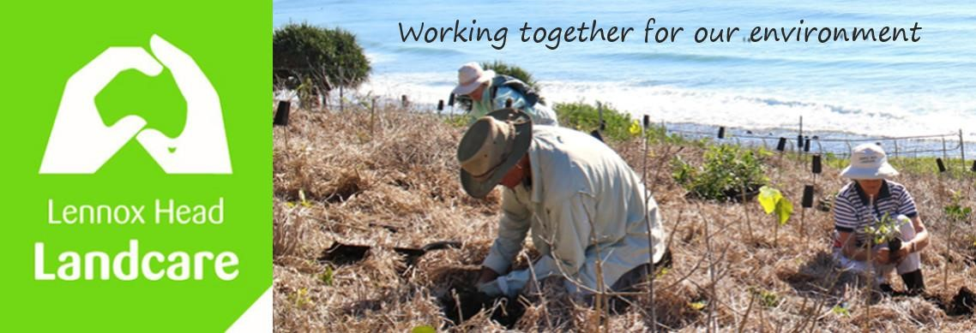

Committee Meeting 27th February 2023 at 1930
Sanctuary Village
Minutes

Attendance: John H, Shaun, Warren, Pat, Barbara, Angela

Apologies: Kelly, Spider

Visitors: Nil

Acknowledgement of Country
Angela

Minutes of Previous Meeting: 5th December 2022
Accepted as a true record. Moved: Angela Seconded: Pat

Matters Arising:

Acknowledgment of Country to be added to website. Angela

Constitution is on website

Nursery. – Shaun is meeting to finalise design details tomorrow; then it is grant searching time.

Weekend working group is self sufficient

Hats are in stock

Reports:
Treasurer - see attached.
$990 received memberships, Council reimbursement, and donations; expenses $942, mainly tools and consumables
Angela is reviewing our membership applications to ensure we meet all our responsibilities under the Act. Nearly done.

Money at bank: $4881
Stocktake: we need to evaluate current replacement costs. Angela, Warren

The amended Treasurers Report was accepted and will be distributed.
Moved: Angela, seconded: John

Skennars
Busy boys. More planting just south of the roundabout. Rehabilitating the rocky outcrop; we have the correct variety of pigface.
There is some dieback in the pandamus; we do not know the aetiology.
Pat has put up some old photos of Boulders on FB.

Lower Point
No report

Waterweeds
It is keeping the team busy

Feedback from BSC Meetings
No report.

General Business:

The draft biodiversity strategy is up. There will be problems financing it. The more who comment the better. Please do:

https://www.yoursayballina.com.au/biodiversity-strategy#:~:text=This%20new%20strategy%20seeks%20to%20promote%20understanding%20of,Ballina%20Shire%20and%20the%20factors%20which%20threaten%20them.

Baseball caps with Landcare embraided on them are about $10 each min 50. They will be for sale. Shaun will pursue sourcing with a cost in line with above. Moved: Warren, Seconded: Pat

4WD on 7 Mile has finally been put on public exhibition. Malcolm has provided a copy of his submission
The staff report is inadequate being quite dismissive of the environmental impacts, despite environmental protection being one of the key purposes for the Ballina Coastal Reserve. Past staff reports have been more balanced. Council does make a lot of money out of the permits though.

Correspondence in: Nil
Correspondence Out: Nil

New Business:

Equipment Storage CoastCare will share a container with us. We have applied for a grant to replace the existing one which is riddled with holes.

Nursery Info on website Shaun to send to Warren for uploading

LHLC Species List Warren to convert to Excel

Meeting Closed: 8.30 pm

Next Meeting: 29th May 2023

